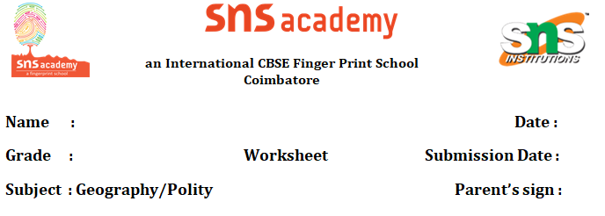

**Chapter- Locating places on Earth I & II.**

**Part A: Objective Questions (40 questions)**

**I. Multiple Choice Questions (20 questions)**

1. The imaginary horizontal lines on a globe are called:  
   a) Longitudes  
   b) Meridians  
   c) Latitudes  
   d) Poles
2. The Prime Meridian is located at:  
   a) 0° latitude  
   b) 90° longitude  
   c) 180° latitude  
   d) 0° longitude
3. The line that divides Earth into the Northern and Southern Hemispheres is the:  
   a) Prime Meridian  
   b) Equator  
   c) Tropic of Cancer  
   d) International Date Line
4. How many time zones are there in the world?  
   a) 12  
   b) 24  
   c) 36  
   d) 18
5. The standard time of India is based on:  
   a) 75° E  
   b) 82.5° E  
   c) 90° E  
   d) 66.5° E
6. Which symbol represents a railway line on a map?  
   a) ––––  
   b) =====  
   c) . . . .  
   d) xxxxx
7. A sketch is:  
   a) Drawn to scale  
   b) Not drawn to scale  
   c) Always accurate  
   d) Made using satellites
8. A small-scale map shows:  
   a) Less area in detail  
   b) Large area with less detail  
   c) Street map  
   d) None of the above
9. The total number of longitudes is:  
   a) 180  
   b) 360  
   c) 90  
   d) 270
10. The symbol for a police station is:  
    
11. The latitudes run from:  
    a) North to South  
    b) East to West  
    c) South to East  
    d) Pole to Pole
12. Which of the following is **not** a conventional symbol?  
    
13. The map showing only one city is:  
    a) Political map  
    b) Physical map  
    c) Sketch  
    d) Plan
14. Which line is opposite the Prime Meridian?  
    a) 90° W  
    b) International Date Line  
    c) Equator  
    d) Tropic of Capricorn
15. If it is 12 noon in Greenwich, what time is it in India (82.5°E)?  
    a) 5:30 PM  
    b) 2:30 AM  
    c) 12:30 PM  
    d) 6:00 AM
16. Which map element tells the direction?  
    a) Key  
    b) Scale  
    c) Compass rose  
    d) Legend
17. Which of the following is a feature of a plan?  
    a) Drawn without scale  
    b) Rough sketch  
    c) Accurate and detailed  
    d) Shows the globe
18. The longest latitude is:  
    a) Tropic of Capricorn  
    b) Equator  
    c) Arctic Circle  
    d) Antarctic Circle
19. The line that helps calculate Indian Standard Time is called:  
    a) Greenwich Meridian  
    b) Equator  
    c) 82.5° E longitude  
    d) Tropic of Cancer
20. The symbol  represents:  
    a) Temple  
    b) Mosque  
    c) Church  
    d) School

**II. Fill in the Blanks (10 questions)**

1. The Earth is divided into _______ time zones.
2. _______ is the zero degree latitude.
3. A _______ shows directions, scale, and symbols.
4. The International Date Line lies on _______ degree longitude.
5. A _______ is a rough drawing without scale.
6. The total number of latitudes is _______.
7. _______ meridian is the base for IST.
8. _______ signs are used to show features on a map.
9. A map’s _______ explains the symbols used.
10. 1 hour time difference is caused by _______ degrees of longitude.

**III. Match the Following (5 questions)**

| **A** | **B** |
| --- | --- |
| 31. Equator | a. 0° longitude |
| 32. Prime Meridian | b. Compass |
| 33. Legend | c. 0° latitude |
| 34. Direction | d. Shows symbols |
| 35. Sketch | e. Rough drawing |

**IV. Identify and Correct the Error (5 Questions)**

*Read each statement carefully. If it is correct, write “Correct”. If there is an error, rewrite the statement in the correct form.*

1. The direction of Earth's rotation is from the west towards the east.  
       **Answer:** ___________________________
2. Parallels of latitude are another name for meridians.  
       **Answer:** ___________________________
3. A plan is used to represent detailed features of a large region such as a country.  
       **Answer:** ___________________________
4. Indian Standard Time (IST) is ahead of Greenwich Mean Time (GMT) by 5 hours and 30 minutes.  
       **Answer:** ___________________________
5. Map symbols and conventional signs are universally identical in every country.  
       **Answer:** ___________________________

**Part B: Short Answer Questions (5 questions)**

**2-Mark Questions**

1. Define longitude and latitude.
2. What is Indian Standard Time and why is it important?
3. Write any two differences between sketch and plan.

**3-Mark Questions**

1. Explain the importance of time zones. How many time zones are there and why?
2. Draw any 4 conventional signs and write what they represent.